Student Task 5 Dynamic ZABBIX Maps for JumpingJIVE
User Manual
Written by Jingyao Su
Latest version updated on 26.03.2019

1. Introduction

1.1 Basics
The scripts are written in Python 3, consisting of 3 .py files:
‘dynamicmap.py’
‘login.py’
‘images.py’
Main functions shall be realized in ‘dynamicmap.py’. The other two work as modules.

1.2 Functions
1. Get host information
2. Create images as background of maps
3. Create Wettzell station map and EVN global map
4. Determine station/antennas location on the map
5. Add or delete stations/antennas on the map
6. Update and delete maps
7. Possibility to switch on/off the antennas on the map

1.3 Methods
1. Python IDE
Scripts can be run with all inputs updated firstly at certain location (Definition part of ‘dynamicmap.py’).
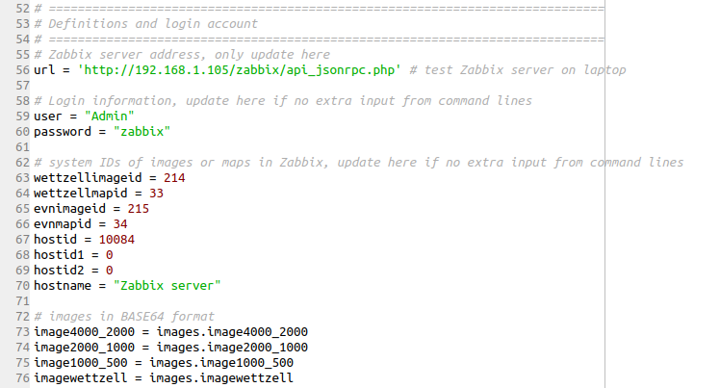
Fig.1 Definition part of scripts shown in Python IDE
2. Command lines
Scripts can be called and run from Command Prompt (Ubuntu Terminal) by command line argument.
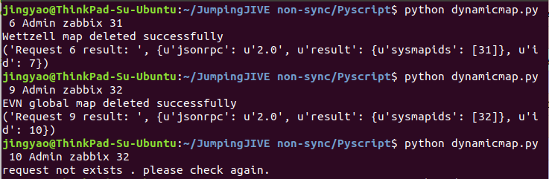
Fig.2 Command line argument in Ubuntu Terminal

1.4 Environment
Since Python 3 should be already installed in the Ubuntu Linux system, only one third-party Python package (requests) is needed to be installed in extra.
To see which version of Python 3 you have installed, open a command prompt and run
$ python3 --version
If you are using Ubuntu 16.10 or newer, then you can easily install Python 3.6 with the following commands:
$ sudo apt-get update
$ sudo apt-get install python3.6
If you’re using another version of Ubuntu (e.g. the latest LTS release), to install Python 3.6:
$ sudo apt-get install software-properties-common
$ sudo add-apt-repository ppa:deadsnakes/ppa
$ sudo apt-get update
$ sudo apt-get install python3.6
Python 3.4 and later include pip by default. To see if pip is installed, open a command prompt and run
$ command -v pip
If no pip is installed, run
$ apt-get install pip
Then to install ‘requests’ package, run
$ pip install requests

2. Definitions and Zabbix login
Basic parameters should be known and input before execution, including:
‘url’: Zabbix server address
‘user’: User account of Zabbix system
‘password’: User password of Zabbix system
‘wettzellimageid’: background image ID for Wettzell station map
‘wettzellmapid’: map ID of Wettzell station in Zabbix system
‘evnimageid’: background image ID for EVN global map
‘evnmapid’: map ID of EVN global network in Zabbix system
‘hostid’: host ID of telescope/antenna to be monitored
‘hostid1’: host ID of twin telescope 1 at Wettzell station
‘hostid2’: host ID of twin telescope 2 at Wettzell station
‘hostname’: name of host whose information is expected to be obtained
For execution method of Python IDE, all above information should be updated in the ‘Definition and login account’ part of ‘dynamicmap.py’ (Fig.1).
To select which request is expected to run, the sequence number of request should be updated in ‘Main function’ part of ‘dynamicmap.py’ (Fig.3).
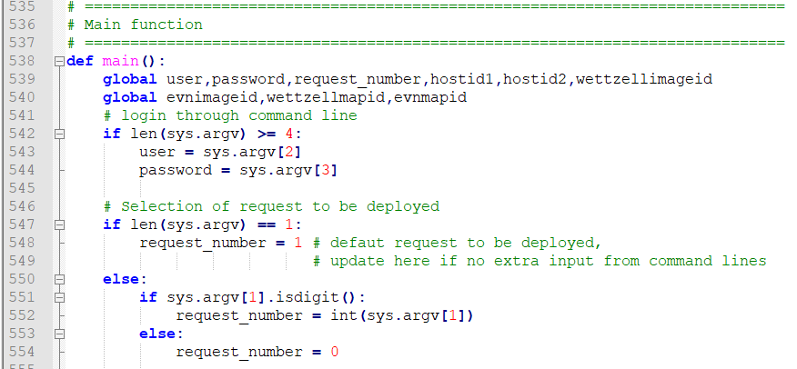
Fig.3 Main function part of scripts

3. Get host information
Request 1 is used to get host information such as IP address and host ID. Default host is the Zabbix server. Scripts can also be used to get other host information by changing the host name “Zabbix server” to others.
How to use:
1. Python IDE
- Update Zabbix system user account and password, URL of Zabbix server, name of host
- Set request number (line 548) to 1
- Run ‘dynamicmap.py’
2. Command line
Command line argument format:
“python dynamicmap.py 1 user password hostname”
Or
“python dynamicmap.py 1” for default configuration
For example:
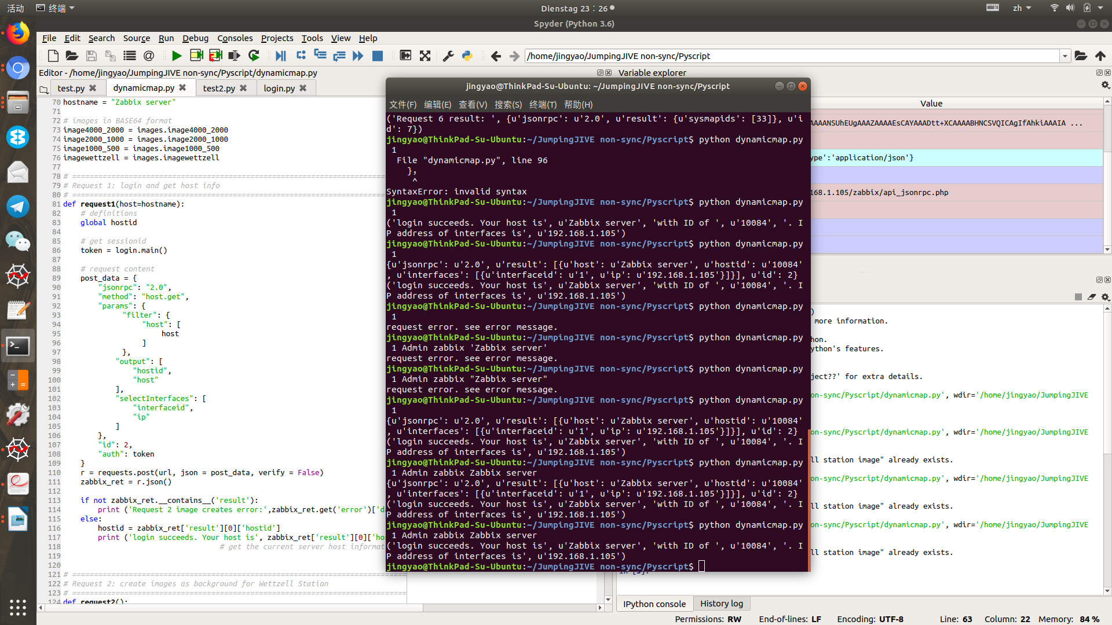
Result is the host information including host name, host ID and IP address.
Error analysis:
When host name is wrongly input, the result shows “request error.”
When login account is error, the result shows “Not authorised”.
When request number is wrongly input or missed, the result shows “request not exists”

4. Create new images
Request 2 and 3 are used to create images as map background, for Wettzell Station and EVN global network respectively.
How to use:
1. Python IDE
- Update Zabbix system user account and password, url of Zabbix server
- Update image information in BASE64 formation in ‘images.py’
- Set request number (line 548) to 2 or 3
- Run ‘dynamicmap.py’
2. Command line
Command line argument format:
“python dynamicmap.py 2 user password”
Or
“python dynamicmap.py 2” for default configuration
For example:
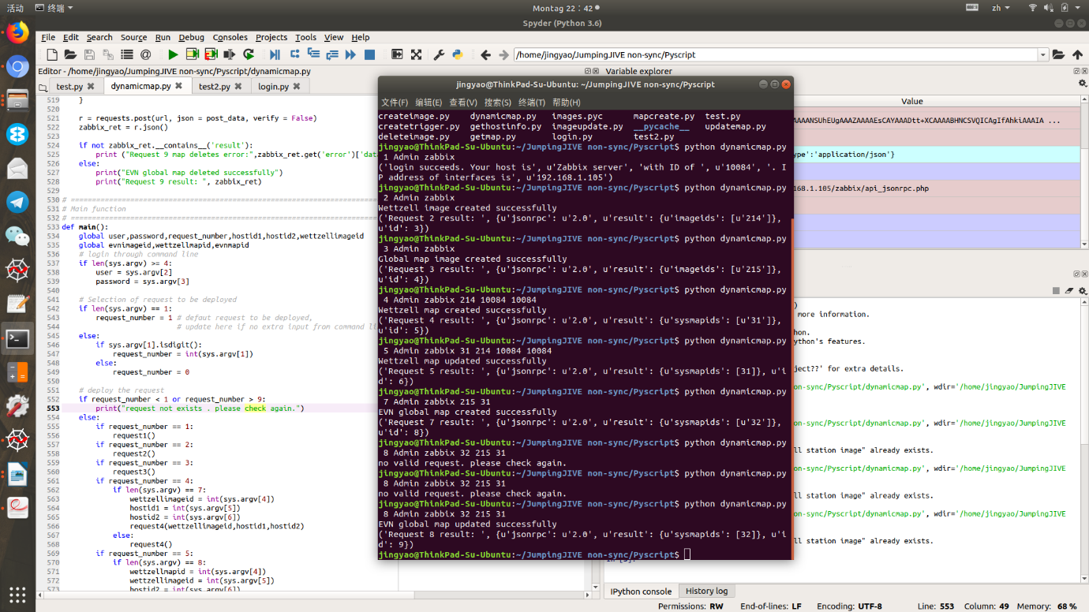
Result is the image ID of new images created (“wettzellimageid” or “evnimageid”).
Error analysis:
When image formation is wrongly input, the result shows “request error.”
When login account is error, the result shows “Not authorised”.
When request number is wrongly input or missed, the result shows “request not exists”

5. Create new maps
Request 4 and 7 are used to create maps for Wettzell Station and EVN global network respectively.
For Request 4,
How to use:
1. Python IDE
- Update Zabbix system user account and password, url of Zabbix server
- Update image ID of Wettzell station, host ID of twin telescopes at Wettzell station
- Set request number (line 548) to 4
- Run ‘dynamicmap.py’
2. Command line
Command line argument format:
“python dynamicmap.py 4 user password wettzellimageid hostid1 hostid2”
Or
“python dynamicmap.py 4” for default configuration
For example:
Result is the map ID of new created map for Wettzell station(”wettzellmapid”).
Error analysis:
When image ID or host IDs are wrongly input, the result shows “request error”.
When login account is error, the result shows “Not authorised”.
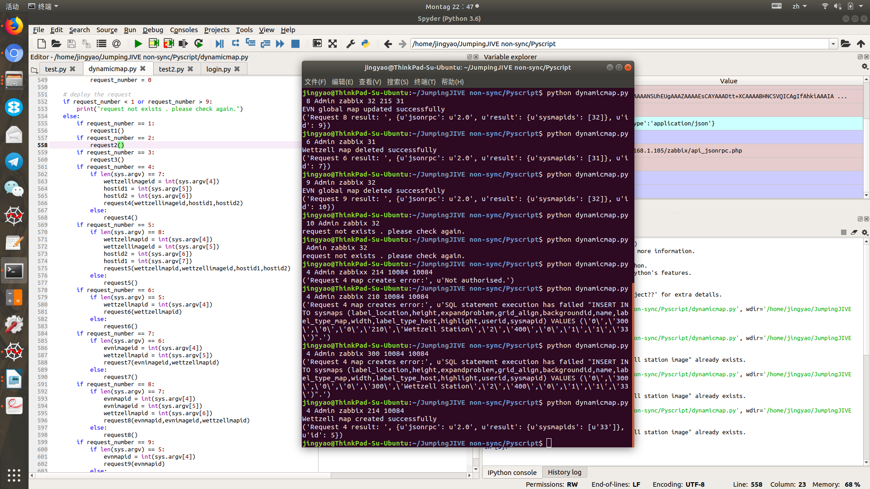
When request number is wrongly input or missed, the result shows “request not exists”
For Request 7,
How to use:
1. Python IDE
- Update Zabbix system user account and password, url of Zabbix server
- Update image ID of EVN global network, map ID of Wettzell station
- Set request number (line 548) to 7
- Run ‘dynamicmap.py’
2. Command line
Command line argument format:
“python dynamicmap.py 7 user password evnimageid wettzellmapid”
Or
“python dynamicmap.py 7” for default configuration
For example:
Result is the map ID of new created map for EVN global network(“evnmapid”).
Error analysis:
When image ID or map IDs are wrongly input, the result shows “request error”.
When login account is error, the result shows “Not authorised”.
When request number is wrongly input or missed, the result shows “request not exists”

6. Update maps and antenna button operations
Request 5 and 8 are used to update maps for Wettzell Station and EVN global network respectively, and antenna buttons can be therefore controlled.
For Request 5,
How to use:
1. Python IDE
- Update Zabbix system user account and password, url of Zabbix server
- Update image ID of Wettzell station, map ID of Wettzell station, host ID of twin telescopes at Wettzell station
- Update information of antenna/telescope/station/submap on the map
- Set request number (line 548) to 5
- Run ‘dynamicmap.py’
2. Command line
Command line argument format:
“python dynamicmap.py 5 user password wettzellmapid wettzellimageid hostid1 hostid2”
Or
“python dynamicmap.py 5” for default configuration
How to define antenna button:
The antenna/telescope/station is defined as map element (element type: host, submap etc.) on the map. For the map of Wettzell station, individual antenna is shown as ‘host’ and can be modified through scripts of line 304 to 335.
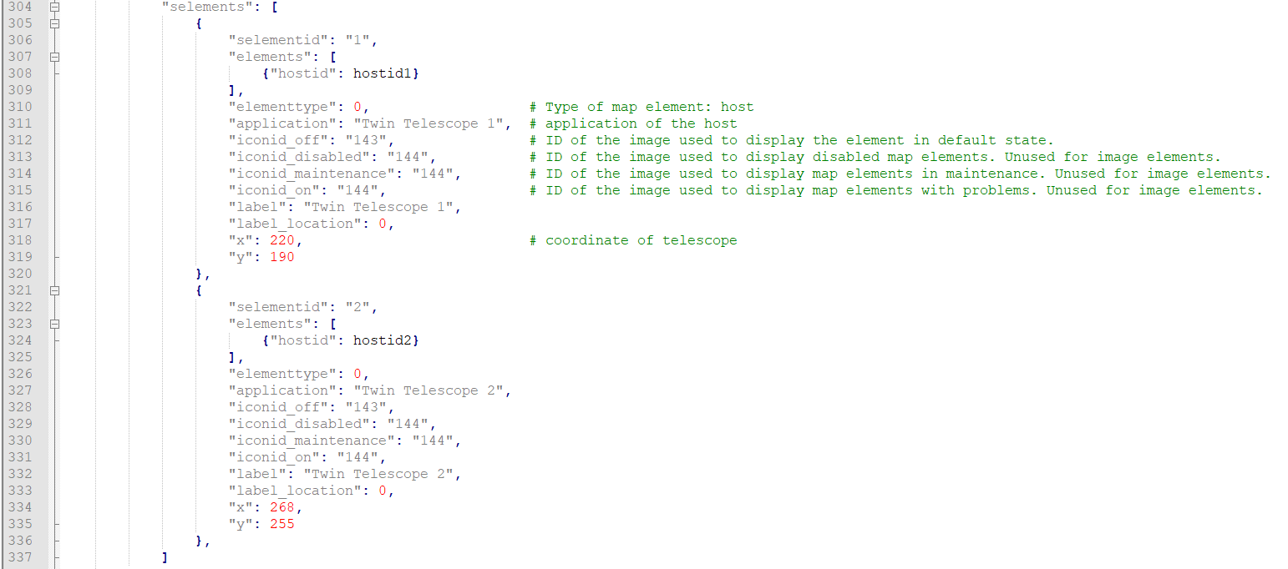
If an antenna is expected to be switched off, delete certain lines.
If an antenna is expected to be switched on, add certain lines.
More about element parameters, see developer manual.
For example:
Result is the map ID of updated map for Wettzell station.
Error analysis:
When image ID or host IDs are wrongly input, the result shows “request error”.
When login account is error, the result shows “Not authorised”.
When request number is wrongly input or missed, the result shows “request not exists”
For Request 8,
How to use:
1. Python IDE
- Update Zabbix system user account and password, url of Zabbix server
- Update map ID of EVN global network, image ID of EVN global network, map ID of Wettzell station
- Update information of antenna/telescope/station/submap on the map
- Set request number (line 548) to 8
- Run ‘dynamicmap.py’
2. Command line
Command line argument format:
“python dynamicmap.py 8 user password evnmapid evnimageid wettzellmapid”
Or
“python dynamicmap.py 8” for default configuration
How to define antenna button:
The antenna/telescope/station is defined as map element (element type: host, submap etc.) on the map. For the map of EVN global network, individual station is shown as submap and can be modified through scripts of line 478 to 494.
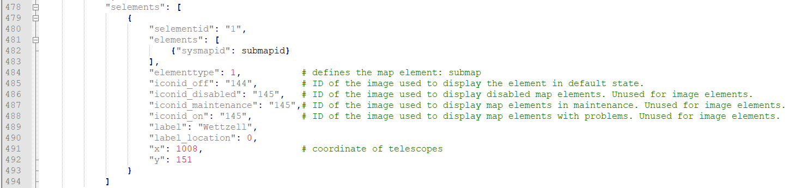
If a station is expected to be switched off, delete certain lines.
If a station is expected to be switched on, add certain lines.
More about element parameters, see developer manual.
For example:
Result is the map ID of updated map for EVN global network.
Error analysis:
When image ID or map IDs are wrongly input, the result shows “request error”.
When login account is error, the result shows “Not authorised”.
When request number is wrongly input or missed, the result shows “request not exists”

7. Delete maps
Request 6 and 9 are used to delete maps for Wettzell Station and EVN global network respectively.
For Request 6,
How to use:
1. Python IDE
- Update Zabbix system user account and password, url of Zabbix server
- Update map ID of Wettzell station
- Set request number (line 548) to 6
- Run ‘dynamicmap.py’
2. Command line
Command line argument format:
“python dynamicmap.py 6 user password wettzellmapid”
Or
“python dynamicmap.py 6” for default configuration
For example:
Result is the map ID of deleted map for Wettzell station.
Error analysis:
When image ID or host IDs are wrongly input, the result shows “request error”.
When login account is error, the result shows “Not authorised”.
When request number is wrongly input or missed, the result shows “request not exists”
For Request 9,
How to use:
1. Python IDE
- Update Zabbix system user account and password, url of Zabbix server
- Update map ID of EVN global network
- Set request number (line 548) to 9
- Run ‘dynamicmap.py’
2. Command line
Command line argument format:
“python dynamicmap.py 9 user password evnmapid”
Or
“python dynamicmap.py 9” for default configuration
For example:
Result is the map ID of updated map for EVN global network.
Error analysis:
When image ID or map IDs are wrongly input, the result shows “request error”.
When login account is error, the result shows “Not authorised”.
When request number is wrongly input or missed, the result shows “request not exists”

